

**Tribhuvan University**

**Faculty of Humanities and Social Sciences**

**“SneakerStation”**

**E-commerce System**

**A PROJECT REPORT**

**Submitted to**

**Department of Computer Application**

**Divya Gyan College**

***In partial fulfillment of the requirement for the degree of Bachelor in Computer Application***

**Submitted by:**

**Dev Raj Bhatt**

**Exam Roll No: 75102023**

**Registration number: 6-2-751-14-2020**

**Tara Magar**

**Exam Roll No: 75102095**

**Registration number: 6-2-751-33-2020**

**Under the supervision of**

Mrs. Annu Khanna Nakarmi



**Tribhuvan University**

**Faculty of Humanities and Social Sciences**

**“SneakerStation”**

**E-commerce System**

**A PROJECT REPORT**

**Submitted to**

**Department of Computer Application**

**Divya Gyan College**

***In partial fulfillment of the requirement for the degree of Bachelor in Computer Application***

**Submitted by:**

**Dev Raj Bhatt**

**Exam Roll No: 75102023**

**Registration number: 6-2-751-14-2020**

**Tara Magar**

**Exam Roll No: 75102095**

**Registration number: 6-2-751-33-2020**

**Under the supervision of**

Mrs. Annu Khanna Nakarmi



**Tribhuvan University**

**Faculty of Humanities and Social Sciences**

**Divya Gyan College**

**Supervisor’s Recommendation**

This is to certify that the Project report entitled “SneakerStation/E-Commerce” submitted by **Dev Raj Bhatt Symbol No 75102033** and **Tara Magar Symbol No 75102095** to the Department of Computer Application, Divya Gyan College, Kathmandu, Nepal towards the partial fulfillment of the requirements for the award of Degree of Bachelor of Computer Application (BCA) is an original work carried out by them under my supervision and guidance.

……………………….

Signature

Mrs. Annu Khanna Nakarmi

Coordinator

Divya Gyan College

(Supervisor)



**Tribhuvan University**

**Faculty of Humanities and Social Sciences**

**Divya Gyan College**

**LETTER OF APPROVAL**

This is to certify that this project prepared by Dev Raj Bhatt & Tara Magar entitled “SneakerStation / E-commerce” in partial fulfillment of the requirements for the degree of bachelor of computer application has been evaluated in our opinion. It is satisfactory in the scope and quality as a project for the required degree.

|  |  |
| --- | --- |
| ……………………………….  Signature  Mrs. Annu Khanna Nakarmi  Coordinator  Divya Gyan College  Kamaladi, Kathmandu | …………………………………  Signature  Mr. Shailendra Basnet  Director  Divya Gyan College  Kamaladi, Kathmandu |
| ……………………………….  Signature  Mr. Sirish Timilsina  Lecturer  Divya Gyan College  Kamaladi, Kathmandu | …………………………………  Signature of External Examiner  Mr. Ananda KC  Assistant Professor  RatnaRajya Laxmi Campus  Pradarshani Marg, Kathmandu |

**Abstract**

In Nepal, there are less single-vendor websites providing good quality of products especially footwear. Some of the websites like calibershoes.com, goat.com are there but they are quite expensive and they do not buy or sell secondhand shoes. In order to overcome this issue, we created a website called SneakerStation. Good sneakers are available from SneakerStation at fair prices. This project delves into the creation of a dynamic digital marketplace, where shoe enthusiasts can seamlessly buy and sell their favourite sneakers. In our website, the customer can also sell their own shoes i.e. used or unused which helps customer to trade their shoes with new ones by adding lesser money. We implemented Waterfall model to complete the project as it is a small project. We developed process modeling and data flow diagrams using Draw.io and Figma. Through the use of the php programming language and the SQL database application, it strives to offer clients a compelling, individualized, visually pleasing, and effectively working footwear purchasing experience. While the SQL database will be in the back-end to handle the data storage process, HTML and CSS will provide the graphical user interface that interacts with the user. Different test case scenarios are designed to validate whether the system we created is implied or not.

**Key Words**- *shoe enthusiasts,* *secondhand shoes, e-commerce platform, affordable*

**Acknowledgement**

We would like to convey our heartfelt appreciation to everyone who have continually supported and encouraged us to continue working on the project. We would like to acknowledge and be thankful to our college Divya Gyan College for giving us this opportunity, especially the teachers of our college, who assisted us in furthering our knowledge in this sector and giving us the opportunity to showcase our skills that we learned in college.

And we’d want to express our special gratitude to our project supervisor Mrs. Annu Khanna Nakarmi, coordinator, who has consistently encouraged, inspired and provided us with wealth of information that has been really beneficial. Her guidance and advice carried us through all the stages of doing our project. We could not have asked for a best project supervisor, counselor, or a mentor.

And we would also like to thank our teachers Dhan Prasad Dahal, Sirish Timilsina and Shailendra Basnet for their brilliant comments and suggestions.

Our completion of this project would not have been possible without the help of our whole class, who offered suggestions, shared their experience, and provided advice throughout the project for which we are grateful.

Finally, we would like to thank our friends for supporting us and being there for us when we needed. We are forever thankful for the unconditional love and support throughout this project and everyday.

Dev Raj Bhatt (Exam Roll No: 75102033)

Tara Magar (Exam Roll No: 75102095)

**List of Abbreviations**

**Abbreviation Full Form**

Html Hypertext Markup Language

CSS Cascading Style Sheets

PHP Hypertext preprocessor

SQL Structured Query Language

XAMPP X-operating system, Apache, MySQL, PHP, Perl

UI User Interface

UX User Experience

OS Operating System

RAM Random Access Memory

GB Giga Byte

CFD Context Flow Diagram

ER Entity Relationship Diagram

DFD Data Flow Diagram

**List of Figures**

Figure 3.1 Waterfall Software Development Model 7

Figure 3.2 Use Case 9

Figure 3.3 Gantt Chart 12

Figure 3.4 ER-Diagram 13

Figure 3.5 Context Level DFD (level 0) 14

Figure 3.6 Level 1 DFD 15

Figure 3.7 Level 2 DFD 17

Figure 3.8 Architectural Design 18

Figure 3.9 Database Schema Design 19

Figure 3.10 Log In 20

Figure 3.11 Client Side 20

Figure 3.12 Admin Dashboard 21

Figure 3.13 Physical DFD 22

Figure 4 Home page 35

Figure 5 Login page 35

Figure 6 Register page 36

Figure 7 Product deatil page 36

Figure 8 Cart 37

Figure 9 Checkout 37

Figure 10 Payment option 38

Figure 11 Admin login 38

Figure 12 Admin dashboard 39

Figure 13 Add product 39

Figure 14 View product 40

Figure 15 Frontend View 40

Figure 16 Backend View ..41

**List of Tables**

Table 4.1 User login page test cases 26

Table 4.2 User register test cases 26

Table 4.3 Add to cart test cases 27

Table 4.4 User but now test cases 28

Table 4.5 Test case for address 29

Table 4.6 Test case for payment option 29

Table 4.7 Test case for sell us 30

Table 4.8 Test case for launching application 30

Table 4.9 Test case for session 31

Table 4.10 Test case for adding new product 31

Table 4.11 Test case for launching application 32

Table 4.12 Test case for OTP code 32

# Chapter 1: Introduction

## 1.1 Introduction

SneakerStation provides customers with a compelling, personalized, aesthetically appealing, and robustly functioning footwear shopping experience. Good sneakers are available at fair prices. This service also facilitates the affordable purchase and selling of secondhand sneakers.

Our mission is to offer our clients footwear that is both fashionable and in reasonable price. In our website, the customer can also sell their own shoes i.e. used or unused which helps customer to trade their shoes with new ones by adding lesser money.

SneakerStation is a platform where people can know about what’s trending and latest arrival of shoes online. SneakerStation is a platform to showcase varieties of footwear but variation in product appearance and quality may not always be accurate and provide limited physical interaction.

## ****1.2 Problem Statement****

The Single Vendor Shoe E-commerce website faces several challenges that need to be addressed to improve the user experience and ensure customer satisfaction. Compared to a platform with multiple vendors, a website with a single seller may have a smaller assortment of footwear. Customers may not have as many choices and options as a result.

**1.** **No platform that sells both brand new and used shoes**

Finding a single platform that offers both new and used options might be difficult for customers trying to purchase shoes. Despite the availability of multiple platforms for new shoe purchases and different platforms for used shoe purchases, the lack of a unified platform limits the ease and range of options for buyers. Customers must look across many platforms to fill this market vacuum and satisfy their expectations.

**2. Counterfeit and fake products**

Customers in the online retail industry are extremely concerned about the prevalence of phony and counterfeit goods, particularly shoes. It has become more convenient for counterfeiters to sell replica goods because to the growth of online marketplaces, making it challenging for consumers to tell the difference between real and fake goods. This problem damages the reputation of brands for both customers and genuine merchants, erodes consumer trust, and results in financial losses.

## ****1.3 Objectives****

Some objective of this project is to provide a user-friendly website that makes it easy for customers to find the perfect pair of shoes and ensure that the customers have access to the latest styles and trends in footwear and offer customers a wide range of footwear options that cater to different styles, preferences and budgets, including both new and used shoes.

The objective of this project are given below:

* To offer customers a wide range of footwear option
* To offer easy and better user experience while shopping online

## ****1.4 Scope and Limitation****

Every website has a set of distinctive characteristics and restrictions. SneakerStation website offers following scope and lacks following things:

### ****1.4.1 Scope****

* Perform basic function that will allows user to buy and sell shoes.
* The user can buy brand new shoes as well as can sell their old ones within the application.

### ****1.4.2 Limitation****

* Variation in product appearance and quality may not always be accurate
* Limited Physical Interaction
* Supply of used shoes may not meet the required market demand.

## ****1.5 Report Organization****

This report document contains five chapters including this chapter.

**Chapter 1: Introduction**

It gives overall information about the system, its problem, objective, scope and limitation and reports on the system.

**Chapter 2: Background Study and Literature Review**

It gives overall view on the background study and literature review.

**Chapter 3: System Analysis and Design**

It entails system analysis as well as design and represent development process and provides architectural design, database schema design and interface design using different structure diagrams.

**Chapter 4: Implementation and Testing**

It shows established design and architecture where the planned system is transformed from conceptual design into a tangible reality and also shows tools used as well as description of procedures (test case scenarios).

**Chapter 5: Conclusion and Future Recommendations**

It describes about the outcome of this system as well as the future recommendations for the E-commerce System i.e. SneakerStation.

# Chapter 2: Background Study and Literature Review

## 2.1 Background Study

E-commerce is a boom in the modern business era. E-commerce stands for electronic commerce. It is leading to modernization, a complete change in traditional way of doing business. E-commerce refers to the trading of goods or services directly to the client from a vendor's website on the Internet. The portal accepts payments through credit card, debit card, or EFT (Electronic fund transfer) and uses a digital shopping cart or digital shopping basket system. E-commerce is defined more fully as the use of digital information processing and electronic communications in business transactions to create, transform, and redefine relationships for value creation between or among organizations as well as between organizations and individuals.

## ****2.2 Literature Review****

﻿Sometimes the terms E-commerce and E-business are used interchangeably but they are distinct concepts. E-commerce is term used to describe the process of transacting business over the Internet. E-business, on the other hand, involves the fundamental reengineering of the business model into an Internet based-worked enterprise. The difference in the two terms is the degree to which an organization transforms its business operations and practices thorough the use of the Internet. E-business can include any process that a business organization conducts using Internet including internal processes such as employee services and training[1].

The growing use of Internet in New Zealand provides a developing prospect for E-marketers. If E-marketers know the factors affecting online New Zealand buyers’ behaviour, and the relationships between these factors and the type of online buyers, then they can further develop their marketing strategies to convert potential customers into active ones, while retaining existent online customers. This paper is part of larger study, and focuses on factors which online New Zealand buyers keep in mind while shopping online. It also investigates how different types of online buyers perceive websites differently. This research found that website design, website reliability/fulfilment, website customer service and website security/privacy are the four dominant factors which influence consumer perceptions of online purchasing. The four types of online New Zealand buyers; i.e., trial, occasional, frequent and regular online buyers; perceived the four website factors differently. These buyers have different evaluations of website design and website reliability/fulfilment but similar evaluations of website security/privacy issues, which implies that security/privacy issues are important to most online buyers. The significant discrepancy in how online purchasers perceived website design and website reliability accounts for the difference in online purchase frequencies[2].

﻿Internet is changing the way consumers shop and buy goods and services, and has rapidly evolved into a global phenomenon. Many companies have started using the Internet with the aim of cutting marketing costs, thereby reducing the price of their products and services in order to stay ahead in highly competitive markets. Companies also use the Internet to convey, communicate and disseminate information, to sell the product, to take feedback and also to conduct satisfaction surveys with customers. Customers use the Internet not only to buy the product online, but also to compare prices, product features and after sale service facilities they will receive if they purchase the product from a particular store. Many experts are optimistic about the prospect of online business. In addition to the tremendous potential of the E-commerce market, the Internet provides a unique opportunity for companies to more efficiently reach existing and potential customers. Although most of the revenue of online transactions comes from business-to-business commerce, the practitioners of business-to-consumer commerce should not lose confidence[3].

Over the past few decades, the e-commerce landscape has seen dramatic changes that have altered how consumers and firms conduct business. E-commerce was initially primarily restricted to simple online transactions, but quick technological improvements, secure payment gateways, and broad internet access have propelled its explosive expansion. The term "e-commerce," which stands for "electronic commerce," describes the exchange of products and services over the internet. It has spread around the world, overcoming regional barriers and allowing businesses to connect with a huge and varied client base. This trend has been further accelerated by the growth of mobile devices, giving rise to m-commerce, in which transactions take place without a hitch on smartphones and tablets. Major e-commerce players like Amazon, Alibaba, and eBay have become household names, offering an extensive array of products and services. Moreover, the emergence of social commerce, where shopping experiences are integrated with social media platforms, has added a new dimension to online retail. E-commerce has not only provided unparalleled convenience to consumers, allowing them to shop anytime and anywhere, but it has also empowered countless entrepreneurs to start their businesses with minimal overhead costs. The industry has faced challenges such as cybersecurity threats, logistical complexities, and the need for robust customer service. However, continuous innovations, including artificial intelligence-driven personalization, augmented reality-enhanced shopping experiences, and sustainable practices, have propelled e-commerce into a dynamic and ever-evolving ecosystem, fundamentally altering the way commerce is conducted in the modern world[4].

The references and research highlights the distinctions between e-commerce and e-business, emphasizing the transformative impact of the Internet on business models. Focused on the New Zealand context, the study delves into factors influencing online buyer behavior, identifying four buyer types with varying perceptions of website elements. The Internet's global impact on consumer behavior and business practices is discussed, with companies utilizing it for cost-cutting and information dissemination, while consumers leverage it for purchases and comparisons. Projections indicate substantial growth in the e-commerce market, with promising prospects for business-to-consumer transactions. The evolution of the e-commerce landscape, from simple online transactions to the rise of mobile and social commerce, is outlined. Despite challenges like cybersecurity threats, ongoing innovations, such as AI-driven personalization and sustainable practices, contribute to the dynamic nature of e-commerce, fundamentally altering the modern commerce landscape[5].

Scholarly research emphasizes the significance of user experience and interface design in online shoe stores, exploring how these factors influence consumer perceptions and purchasing behavior. Personalization and recommendation systems, which leverage algorithms for tailored product suggestions, are studied for their impact on enhancing the online shopping experience for footwear. Trust and security considerations play a crucial role, with investigations into measures that build consumer trust in online transactions, especially in the context of items like shoes where fit and quality are paramount. Supply chain and inventory management are explored to ensure efficiency in operations and meet the demand for popular shoe models and sizes. Additionally, research delves into the role of social commerce, influencer marketing, and consumer behavior factors such as brand loyalty and style preferences. Cross-border e-commerce, returns policies, and sustainability in the online shoe industry further contribute to the multidimensional exploration of e-commerce systems within this specific market.[6]

# Chapter 3: System Analysis and Design

## 3.1 System Analysis

Given that this project entails designing and implementing a software system, it is crucial to note that we employed the waterfall approach to finish this system. The waterfall approach is a linear and sequential project management methodology for software development. It is often used in projects where the requirements are well-defined and unlikely to change significantly during the development process. The waterfall model follows a strict top-down approach, with each phase of the project being completed before the next one begins.

We will be using Waterfall Approach to develop our system. The waterfall approach can provide a structured framework for executing the project. With a clear understanding of the desired functionality, design, and features of the website, the sequential nature of the waterfall model allows for systematic planning and execution.

It requires the following stages:

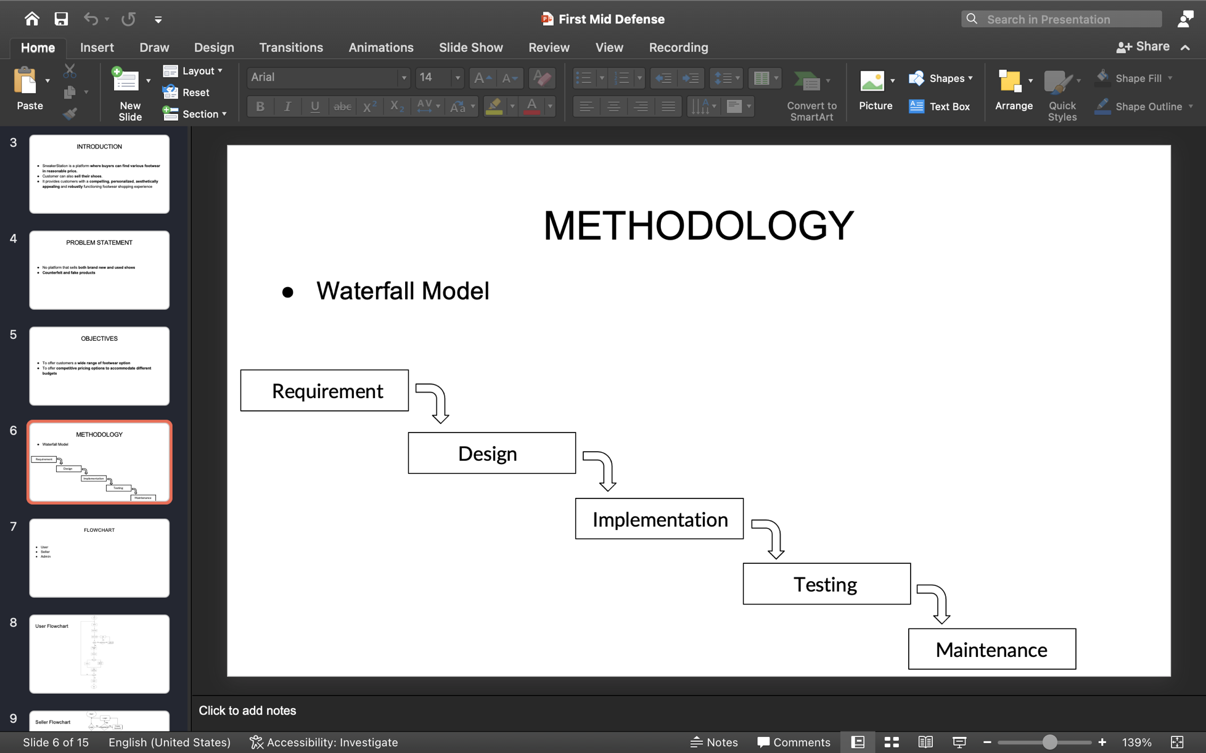

**Figure 3.1 Waterfall Software Development Model**

**Requirement**

All possible requirements of the system to be developed are captured in this phase.

**System Design**

The requirement specifications from first phase are studied in this phase and the system design is prepared. This system design helps in specifying hardware and system requirements and helps in defining the overall system architecture.

**Implementation**

With inputs from the system design, the system is first developed in small programs called units, which are integrated in the next phase. Each unit is developed and tested for its functionality, which is referred to as Unit Testing.

**Testing**

All the units developed in the implementation phase are integrated into a system after testing of each unit. Post integration the entire system is tested for any faults and failures.

**Maintenance**

There are some issues which come up in the client environment. To fix those issues, patches are released. Also to enhance the product some better versions are released. Maintenance is done to deliver these changes in the customer environment.

### ****3.1.1 Requirement Analysis****

At the start of every software project, the project team must understand, finalize and document the features and functionalities required of the end product. These required features and functionalities are often called functional specifications and the process of determining and understanding them is called requirements gathering and analysis. Requirements must be quantifiable, as detailed as possible and relevant to the end product. In addition, they should be clearly documented so the development team has clear expectations and understands required specifications from the beginning.

#### ****i. Functional Requirements****

These are represented or stated in the form of input to be given to the system, the operation performed and the output expected. They are basically the requirements stated but the use which one can see directly in the final product, unlike the non-functional requirements. These are represented or stated in the form of input to be given to the system, the operation

The functional requirements in the projects are mentioned below:

**User/Seller**

* User should be allowed to register for an account and authenticate themselves securely to access the platform's features.
* User should be provided a search functionality that allows them to search for specific products by name, brand, or category.
* User should be provided a catalog of available products, including detailed information about each item, such as price, size, color, and condition (new or used).
* User should get shopping cart functionality that allows them to add items to their cart and complete their purchase at checkout.
* User can integrate with a payment gateway to allow them to securely pay for their purchases using their preferred payment method.
* User should be able to sell products to the admin.
* User gets notification for uploaded product(if approved by admin)

**Admin**

* Admin login validation
* Admin Should be able to add and manage products
* Admin should be able to view order history
* Admin gets notification when a user uploads a new product to sell
* Admin approves/ rejects the products uploaded by the seller

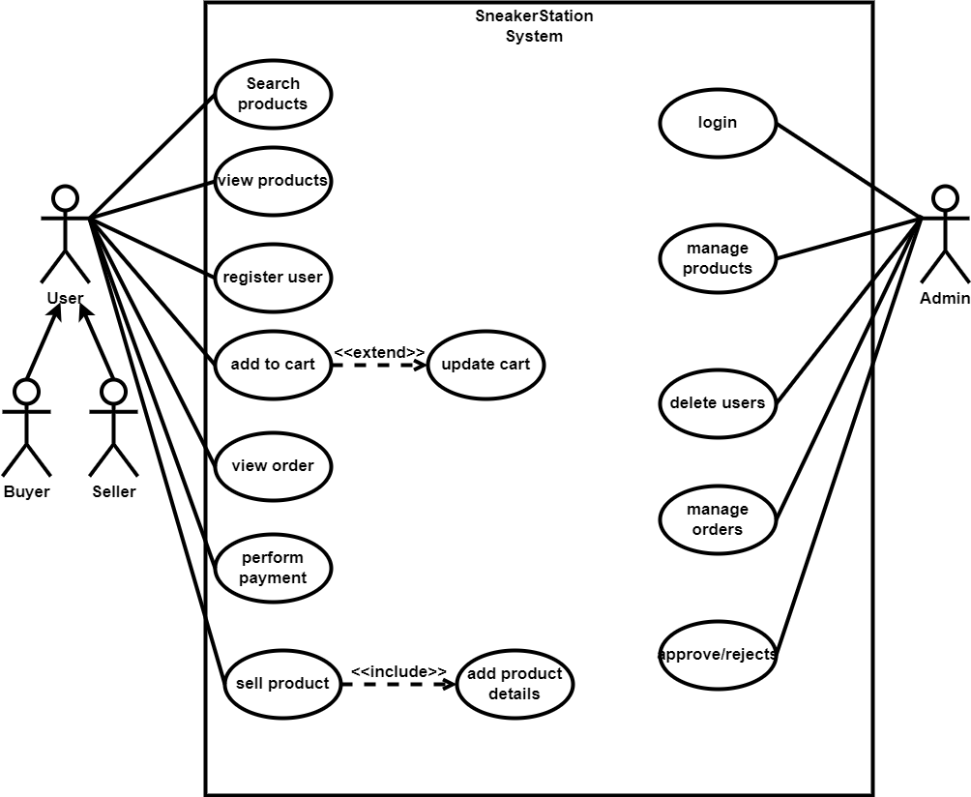

**Figure 3.2 Use Case of E-Commerce System**

#### ****ii. Non-Functional Requirements****

These are basically the quality constraints that the system must satisfy according to the project contract. The priority or extent to which these factors are implemented varies from one project to other.

The non-functional requirements in the projects are mentioned below:

* The website should load quickly and respond promptly to user interactions. Users should be able to navigate through the website smoothly without any lag or delay.
* The website should be able to handle a large number of visitors and transactions without slowing down or crashing.
* The website should be available 24/7 with minimal downtime and maintenance. Users should be able to access the website and make purchases without any interruptions.
* The website should be secure, with robust measures in place to protect user data, including payment information.
* The website should be optimized for mobile devices, as more and more users are accessing e-commerce websites through their smartphones and tablets.
* The website should use up-to-date software and be updated regularly to address any known vulnerabilities.
* The website should have a clear privacy policy that outlines how customer data is collected, stored and used.
* The website should regularly back up all data to protect against data loss.
* The website should ensure that all third-party services, such as payment processors and analytics tool, also meet high security standards.

### ****3.1.2 Feasibility Analysis****

A feasibility study is a preliminary exploration of a proposed project or undertaking to determine its merits and viability. It evaluates the project’s potential for success;

Here, the feasibility study can be carried out in three different ways: technically, operationally, and economically.

#### ****i. Technical Feasibility****

Since it won't be too difficult to obtain the resources needed for both system development and maintenance, it is technically viable. Simple technologies are being used in the project's construction to minimize technological obstacles. The technical requirements for deploying the application are listed below:

* Operating System - Any OS platform
* RAM – 1GB or Higher
* Disk Space - 1GB or Higher
* Web Tools – HTML, CSS, JS
* Editor: VS Code
* Database – MySQL

**For Users**

* Internet Browser – Any browser
* Internet Connection - At least 1 Mbps

#### ****ii. Operational Feasibility****

In this project, we have narrowed our considerations and settled on three key factors. A dependable shipping and delivery system should be in place on the website to guarantee prompt product delivery to customers. In order to assure consumer happiness, the e-commerce company would need to offer top-notch customer service, which would include handling returns and answering any questions or complaints from customers. To guarantee that all shoes sold on the website, whether new or used, are of excellent quality and satisfy customer expectations, quality control procedures should be put in place.

#### ****iii. Economical Feasibility****

This application's development is very commercially viable. We didn't invest a lot of money in its creation. The only thing that has to be done is to create an environment with good monitoring for development. The website can benefit or make money if the following economic possibilities exist. If we ensure that the cost of acquiring new and used shoes is reasonable and competitive to maintain profitability. If we establish a pricing strategy that is both competitive and profitable, taking into account the cost of goods, operational costs, and market demand. If we identify and develop various revenue streams, such as advertising, affiliate marketing, and subscription services, to supplement the revenue generated from shoe sales.

#### ****iv. Schedule Feasibility****

The system that we developed is scheduling feasible as it does not require more time for the development phase. Gantt chart is a type of bar chart showing the start and finish dates of a project's elements such as resources, planning, and dependencies. We created Gantt chart of our project using Figma which is shown below in the figure.

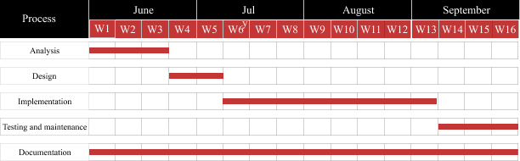

**Figure 3.3 Gantt chart** **of E-commerce System**

### ****3.1.3 Data Modeling(ER Diagram)****

ER model stands for an Entity-Relationship model. It is a high-level data model. In our database system, there are 12 entities which contain a primary key as a unique identifier for each entity and other attribute to show the properties of these entities. Entities are represented as rectangles. The attribute is used to describe the property of an entity. Eclipse is used to represent an attribute. A relationship is used to describe the relation between entities. Diamond or rhombus is used to represent the relationship. The overall relationship between the entities are shown in the ER Diagram below:

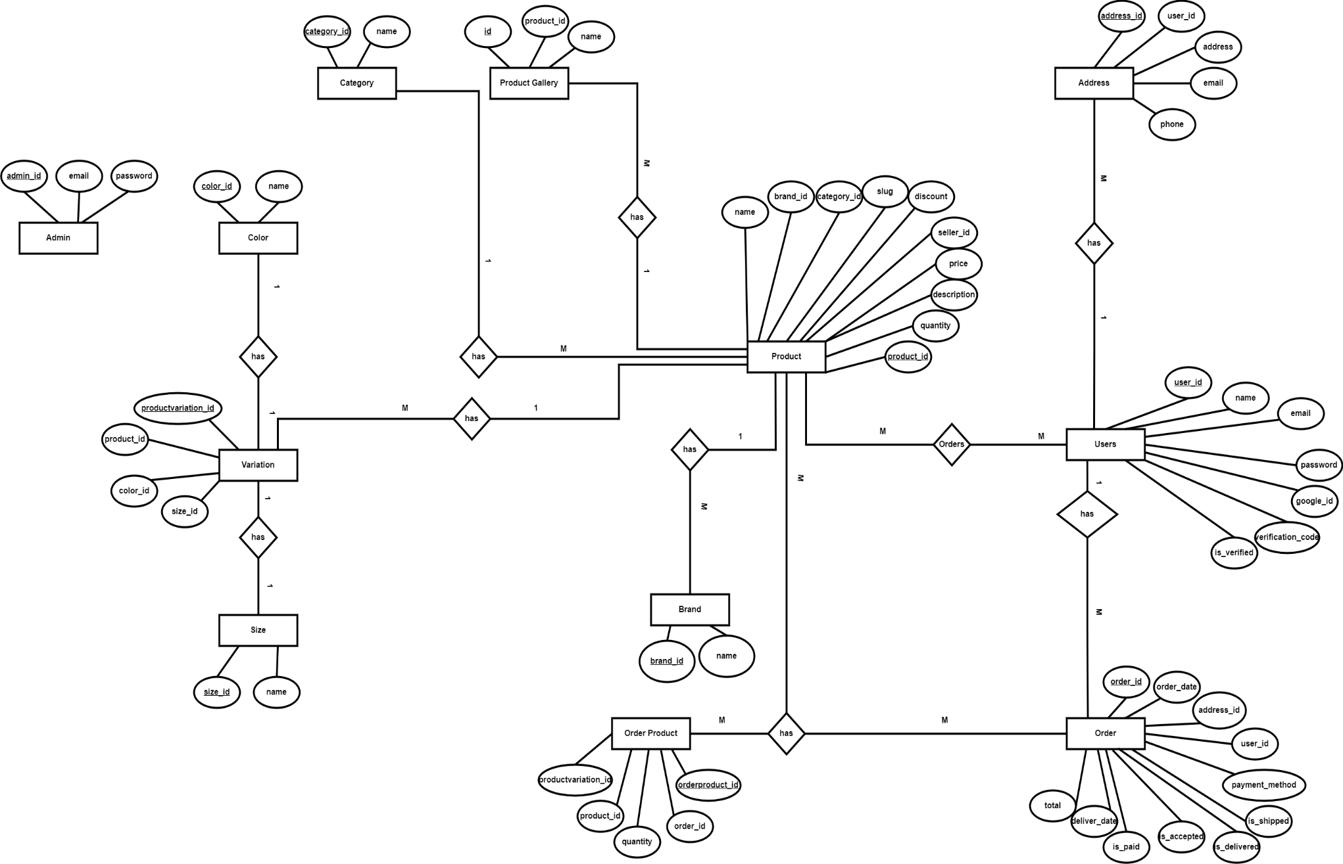

**Figure 3.4 ER-Diagram of** **E-commerce System**

### 3.1.4 Process Modeling (DFD)

Data flow diagrams are used to graphically represent the flow of data in a business information system. DFD describes the processes that are involved in a system to transfer data from the input to the file storage and reports generation. The Context Level DFD provides a more detailed and below comprehensive view of the process and its surrounding input, output and data stores. The following figures can help in visualizing the process flow of our system. The data flow diagram of the system is given below:

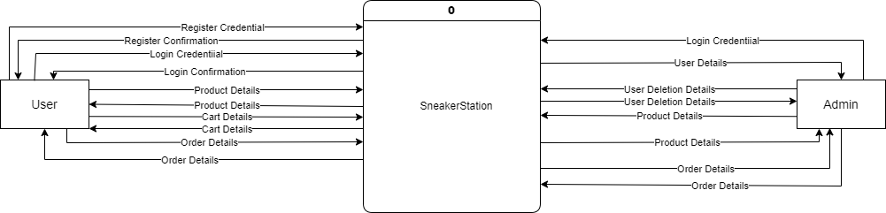

**Figure 3.5 Context Level DFD(level 0)** **of E-commerce System**

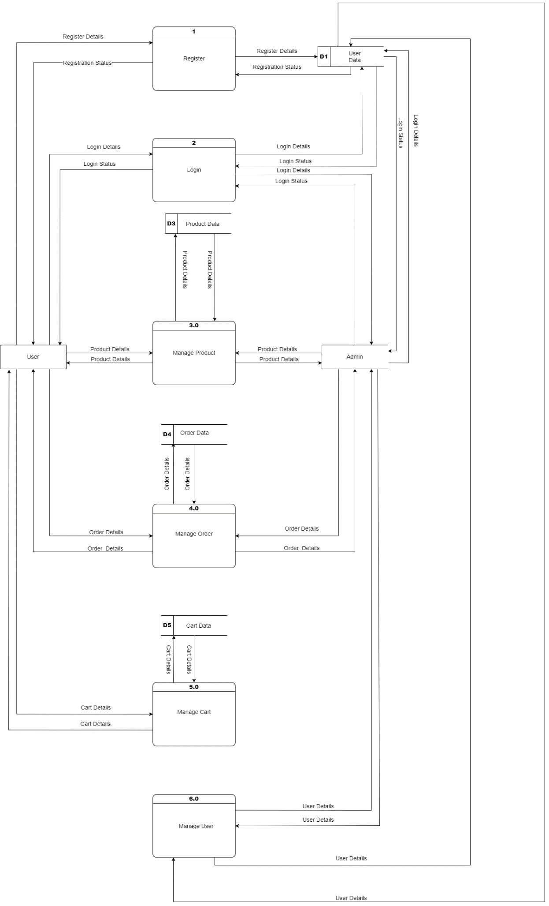**Figure 3.6 Level 1 DFD of E-commerce System**

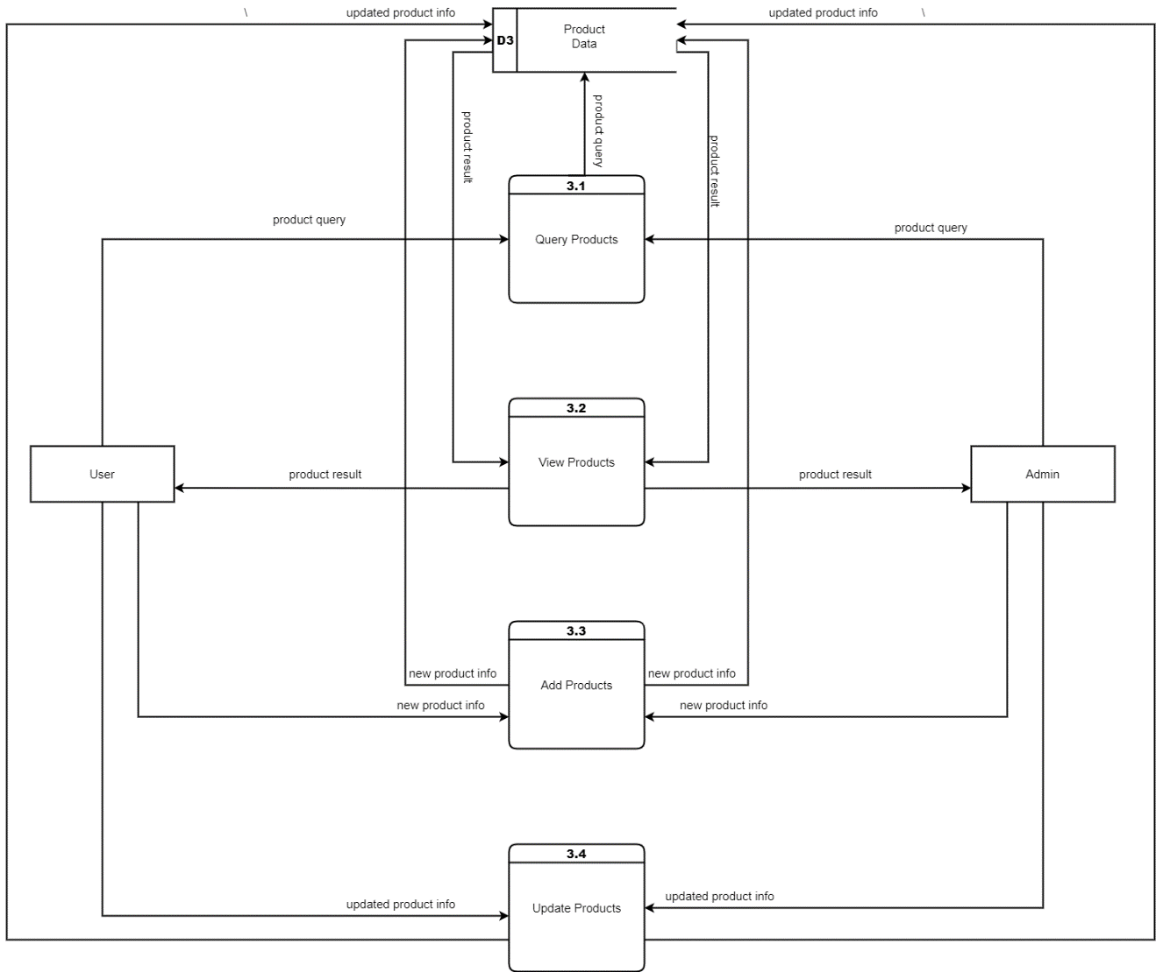

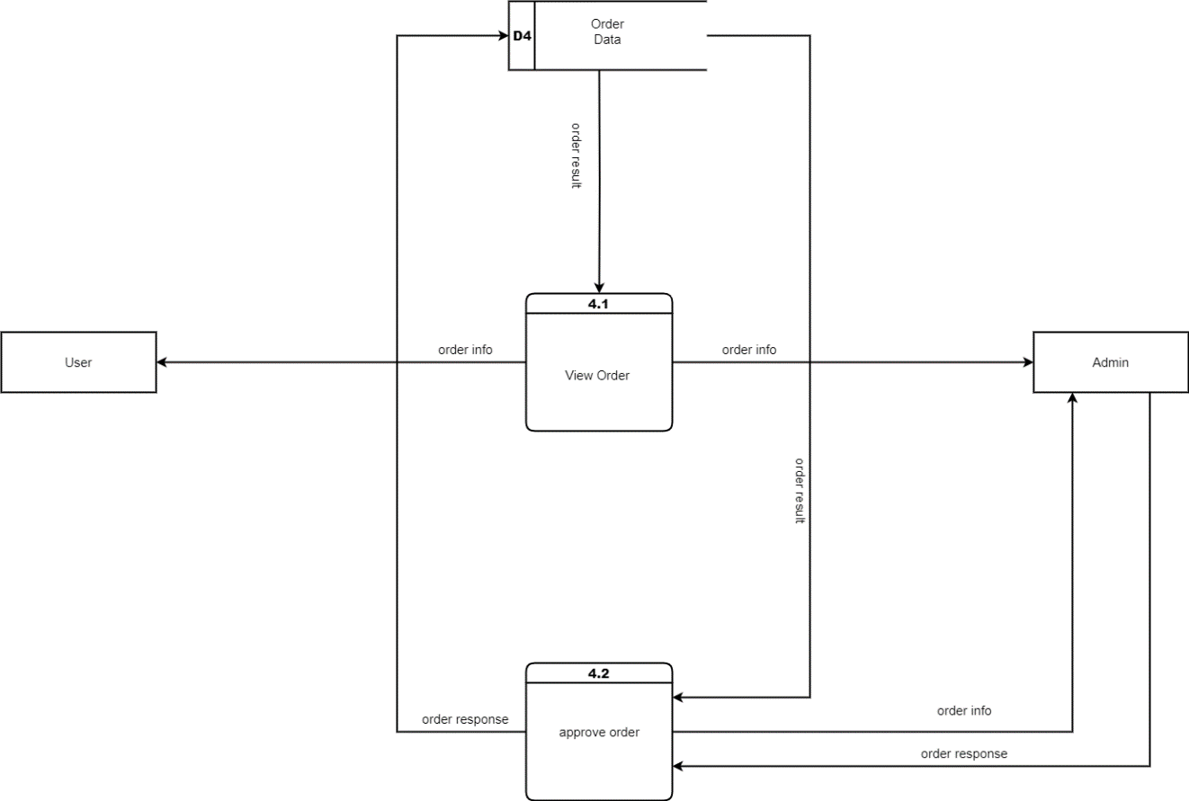

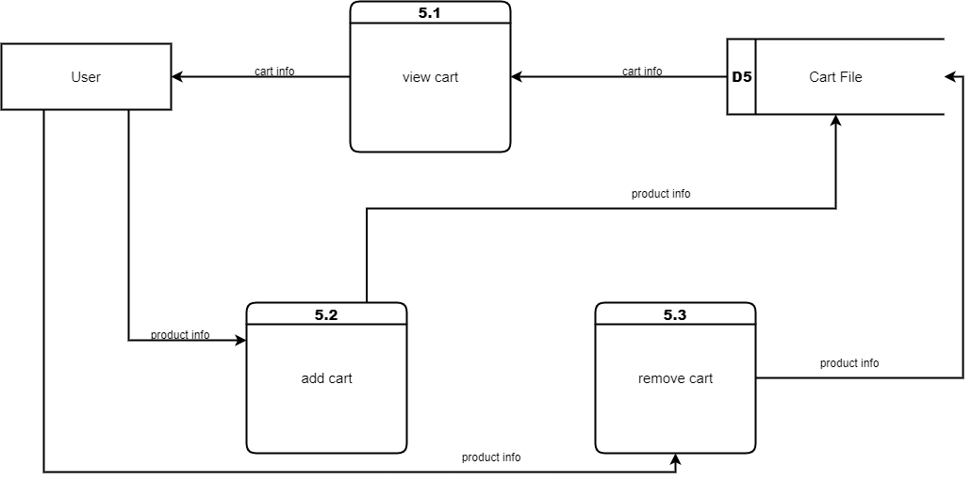

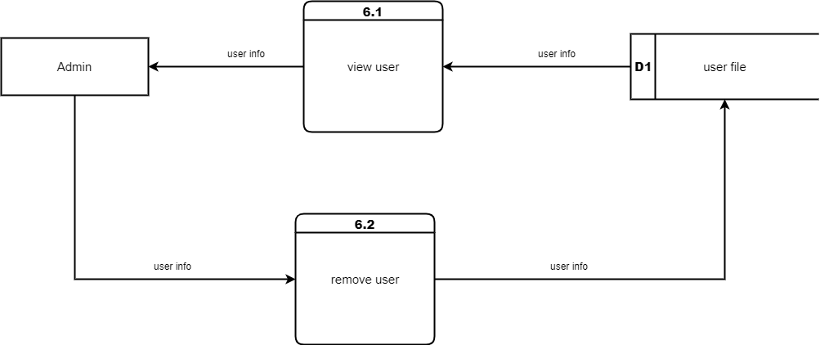

**Figure 3.7 Level 2 DFD of E-commerce System**

## ****3.2 System Design****

Systems design is the process of defining a system's components, including modules, architecture, components, their interfaces, and data, depending on the requirements that have been given.

### ****3.2.1 Architectural Design****

The architectural design of our system is created in a simple way. Users interact with the system through a user-friendly interface. We’ve integrated 3-tier architecture design to create the system which consists of presentation tier, application tier and Database Tier.

In presentation tier, it receives requests from clients and provide them with information. It uses a web browser to interact with other layers and displays output there. Web-based layers are created using programming languages like HTML, CSS, and JavaScript.

In application tier, the request obtained through the presentation layer is processed in-depth in this tier of the architecture, which is also known as the logic tier. Additionally, it communicates with the server that hosts the data. The client's request is processed, formatted, and sent back to the client. We’ve used PHP language in the development.

The last tier of the architecture, commonly referred to as the database tier, is the data tier. In order to make the processed data retrievable at a later time, it is employed to store the data. We’ve used MySQL for creating database.

The following figure illustrates our architectural design of the system.

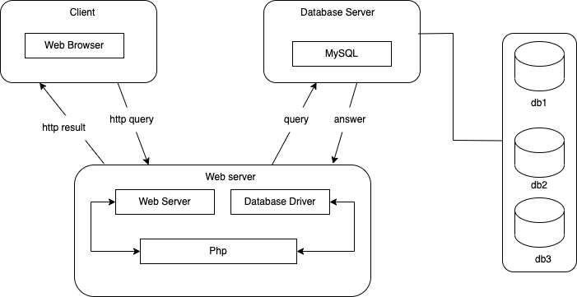

**Figure 3.8 Architectural Design**

### ****3.2.2 Database Schema Design****

Designing a database schema for a web-based application is a critical step that influences the application's performance, scalability, and maintainability. The schema should reflect the application's requirements and ensure efficient data storage and retrieval. A database Schema is basically an abstract concept of the database. The following figure shows the database schema of the system.

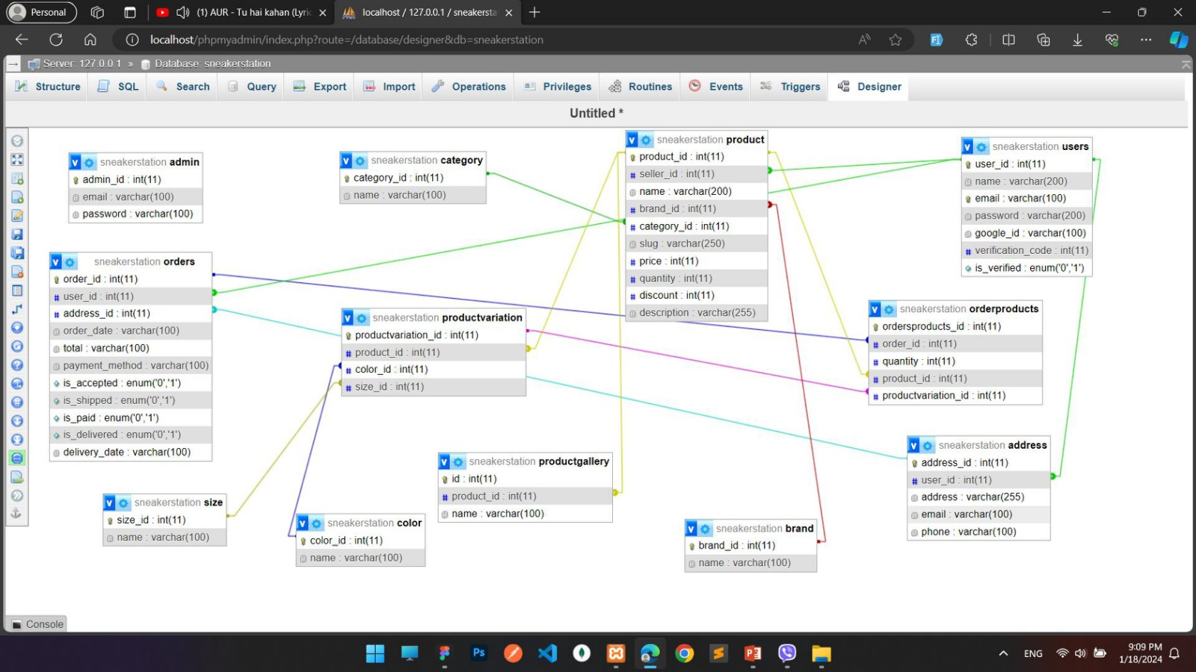

**Figure 3.9 Database Schema Design**

### ****3.2.3 Interface Design****

Designing interface is a critical aspect of creating user-friendly and visually appealing products, whether they are websites, mobile apps, software applications, or any other interactive system. An interface with good design can improve user experience and facilitate understanding. We started by looking over and researching other shoe websites, identifying the drawbacks, and then we developed a prototype of our own website. With the help of Figma, we implemented to build a simple structure of how our website may look like. The following figure illustrates our interface design of the system.

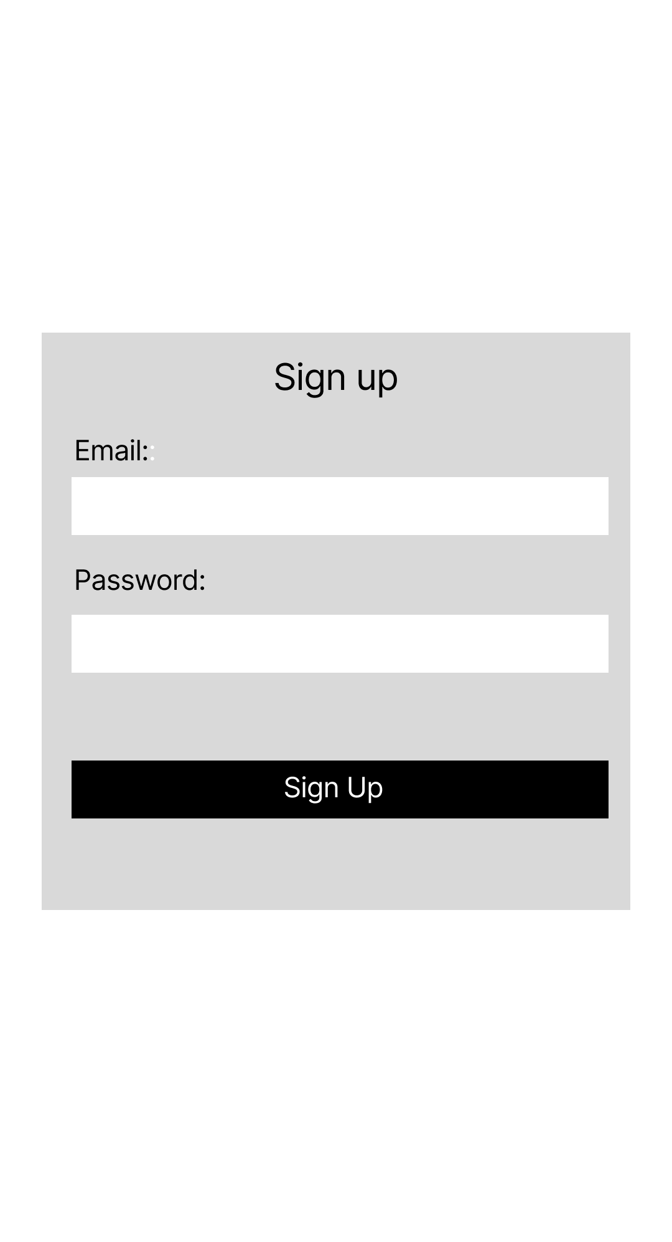

**Figure 3.10 Log In**

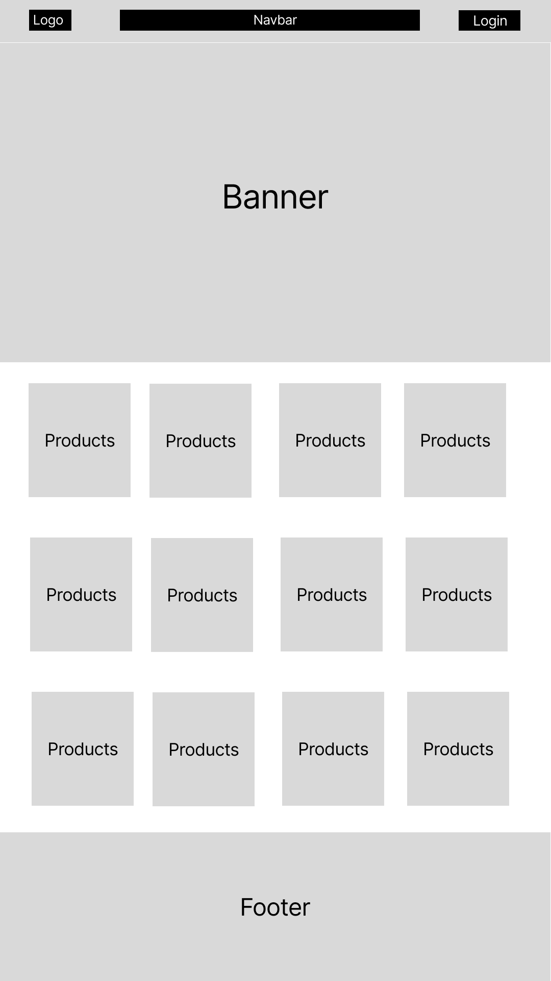

**Figure 3.11 Client Side**



**Figure 3.12 Admin Dashboard**

### ****3.2.4 Physical DFD****

A Physical Data Flow Diagram (DFD) is a representation of how data flows within a system at the physical or hardware level. Unlike logical DFDs, which focus on the system's functionality, physical DFDs provide a detailed view of the system's implementation, showing the actual components and devices involved in the data flow. Physical DFDs are often used in the system design phase to understand how data moves between hardware components. The following figure illustrates the physical flow of the data in a system.

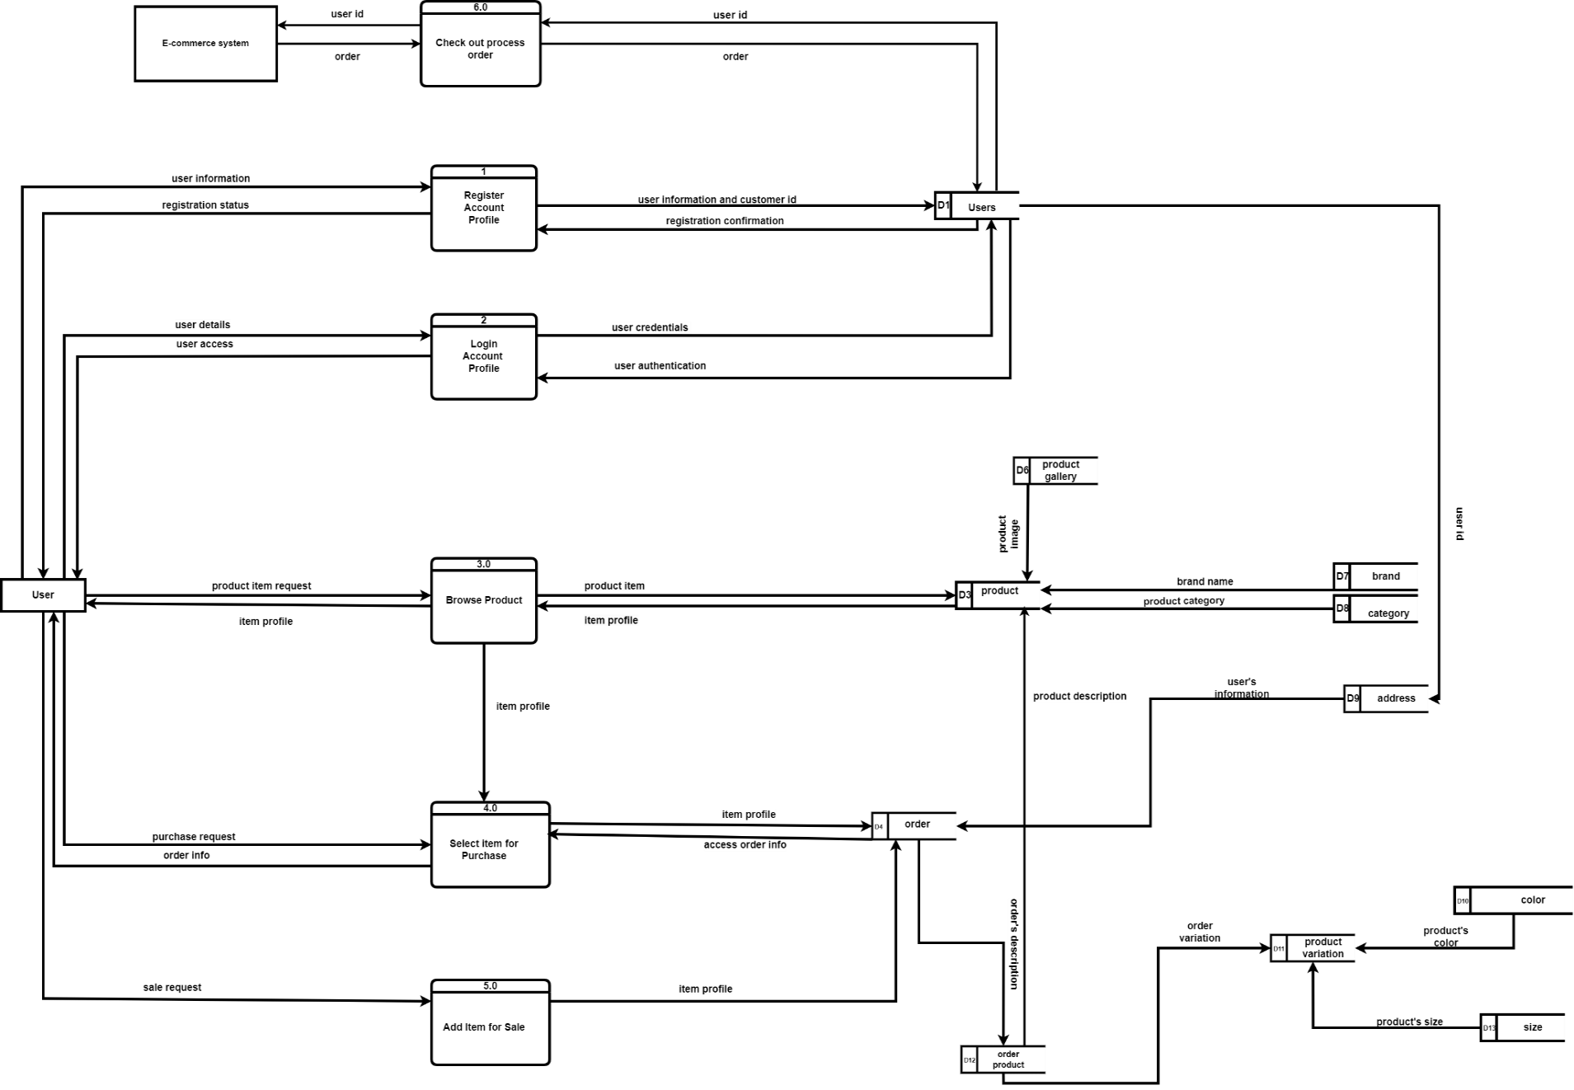

**Figure 3.13 Physical DFD of E-commerce System**

# Chapter 4: Implementation and Testing

## 4.1 Implementation

The implementation phase is a crucial stage in the waterfall method, where the planned system or software solution is transformed from a conceptual design into a tangible reality. It involves translating the detailed requirements and specifications into executable code, integrating various components, and preparing for the deployment of the system.

During the implementation phase, we followed the established design and architecture, employing coding practices and development methodologies to build the system according to the predefined requirements. The primary objective of the implementation phase is to create a functioning system that meets the desired functionality, performance, and quality standards of the system. It involves coding, testing, installation, documentation and training and support. Different tools and technologies have been used to develop the system which are already discussed in the previous chapter.

### ****4.1.1 Tools Used****

Various system tools have been used in developing both the front-end and the back-end of the system. The tools and technologies that we used for developing the system are mentioned below:

**Operating System (OS):**

* **Any OS Platform:** The choice of operating system is flexible and depends on the developers' preferences and the server environment where the application will be deployed. The mentioned technologies are platform-independent, allowing development on Windows, macOS, or Linux.

**Programming Languages:**

* **HTML (HyperText Markup Language**): Used for structuring the content of web pages.
* **CSS (Cascading Style Sheets):** Utilized for styling the HTML elements, defining their layout and appearance.
* **JavaScript (JS):** A versatile scripting language used for enhancing interactivity and dynamic behavior of web pages.
* **PHP:** A server-side scripting language commonly used for web development, especially for building dynamic web pages and handling form data.

**Integrated Development Environment (IDE):**

* **VS Code (Visual Studio Code):** A popular, free source code editor with robust features, extensions, and a powerful debugger. It provides an excellent environment for coding in HTML, CSS, JS, and PHP.

**Database:**

* **MySQL:** An open-source relational database management system (RDBMS) used for storing and managing structured data. MySQL is widely used in web development due to its reliability, scalability, and ease of use.

**UI/UX Design:**

* **Figma**: A cloud-based design tool that allows collaborative UI/UX design, prototyping, and user testing. Designers and developers can work together in real-time, creating visually appealing and user-friendly interfaces.

**Diagrams:**

* **Draw.io**: A free, online diagramming application used for creating various types of diagrams, including flowcharts, network diagrams, and entity-relationship diagrams (ERDs). It's valuable for visualizing system architecture, data flow, and processes.

**Version Control System:**

* **Git**: A distributed version control system used for tracking changes in source code during software development. Git enables collaboration, allows multiple developers to work on a project simultaneously, and helps in managing different versions of the codebase.

These tools and technologies form a comprehensive stack for developing web applications. HTML, CSS, JS, and PHP cover both the front-end and back-end aspects of web development. VS Code serves as an efficient editor, while MySQL handles data storage. Figma and Draw.io assist in the design and visualization process, ensuring a cohesive development workflow. Git facilitates version control, enabling collaborative and organized software development. By using these tools together, developers can create robust and interactive web applications.

### ****4.1.2 Implementation Details of Modules****

Implementing a module in the Ecommerce business involves developing and integrating specific features and functionalities into the online platform. This section highlights key modules that can enhance the efficiency, user experience and operational aspects of the system.

**User Module:** The User module focuses on providing a seamless experience for customers using the platform to buy and sell goods. It includes features such as:

* **Login Form:** Uses user’s credentials like username and password to authenticate the user or they can simply login from their google-account and redirect to the home page.
* **Signup Form:** Users when first try to buy or sell products they have to create an account with personal credentials which are later used to log in to the system. Users can sign up using sign up page with the right credentials.
* **Product selection:** User can select the product of different category.
* **Cart Module:** User can add the desired product to cart, delete the products from the cart and also can change the quantity of the product from the cart.
* **Sell Module :** User can also sell their used shoes
* **Confirmation Module:** User can confirm the order that he receives while selling a product
* **Logout Module:** On the navbar, there is a logout button when clicked it destroys the session and then redirect the user to the home page.

**Admin Module:** The admin module focuses on providing a seamless experience and functionality to the admin.

* **Login Form:** Uses credentials like username and password to authenticate the admin and redirect them to the dashboard.
* **Product Module:** In this module the admin can manage operation related to the products.
* **Variation Module:** In this module the admin can manage operation related to the variation of the products.
* **Order Module:** In this module operation related to the order like accepting or rejecting the order, mark it as shipped, delivered takes place.
* **User Module:** In this module, the admin can delete a user as well as can see all the purchase and order history of the user.
* **Logout Module:** On the navbar, there is a logout button when clicked it destroys the session and redirects to the login page

## ****4.2 Testing****

Testing is software development in a critical process that involves evaluating and validating a software application to ensure that it meets its intended requirements, functions correctly, and is free from defects or errors. The primary goal of testing is to identify and rectify any issues in the software before it is released to end-users, thus improving the software’s quality and reliability.

### ****4.2.1 Test Cases for Unit Testing****

**Unit testing**

Unit testing is a fundamental practice in software development that involves testing individual components or units of code in isolation to ensure they function correctly.

**Table 4.1 User login page test cases**

|  |  |  |  |  |  |
| --- | --- | --- | --- | --- | --- |
| **S.no** | **Test case** | **Input** | **Expected result** | **Actual result** | **Status** |
| 1 | User login with valid credentials | valid email and password | Redirect to homepage | Redirect to homepage | PASS |
| 2 | User login with google account |  | Redirect to homepage | Redirect to homepage | PASS |
| 3 | User login with invalid credentials | invalid email or password | Redirect to login page with invalid credentials error | Redirect to login page with invalid credentials error | PASS |

**Table 4.2 User register test case**

|  |  |  |  |  |  |
| --- | --- | --- | --- | --- | --- |
| **S.no** | **Test case** | **Input** | **Expected result** | **Actual result** | **Status** |
| 1 | User register with valid credentials | valid email, password and confirm password | verification code in the gmail | verification code in the gmail | PASS |
| 2 | User register with existing account | valid email, password and confirm password | user already exists error | user already exists error | PASS |
| 3 | User register with valid verification code | valid verification code | redirect to home page | redirect to home page | PASS |
| 4 | User register with invalid verification code | invalid verification code | invalid verification code | invalid verification code | PASS |

**Table 4.3 Add to cart test case**

|  |  |  |  |  |  |
| --- | --- | --- | --- | --- | --- |
| **S.no** | **Test case** | **Input** | **Expected result** | **Actual result** | **Status** |
| 1 | Add to cart by selecting size and color | size and color | added to cart  message | added to cart message | PASS |
| 2 | Add to cart without selecting size or color |  | please select the desired size and color message | please select the desired size and color message | PASS |
| 3 | Adding to cart if the product with same variation already exists | size and color | the product already exists in the cart with the same size and color message | the product already exists in the cart with the same size and color message | PASS |
| 4 | Add to cart if the user is not logged in | size and color | redirect to login page | redirect to login page | PASS |

**Table 4.4 User buy now test case**

|  |  |  |  |  |  |
| --- | --- | --- | --- | --- | --- |
| **S.no** | **Test case** | **Input** | **Expected result** | **Actual result** | **Status** |
| 1 | Buy now by selecting size and color | size and color | redirect to checkout page | redirect to checkout page | PASS |
| 2 | Buy now without selecting size or color |  | please select the desired size and color message | please select the desired size and color message | PASS |
| 3 | Adding to cart if the product with same variation already exists | size and color | the product already exists in the cart with the same size and color message | the product already exists in the cart with the same size and color message | PASS |
| 4 | Buy now if the user is not logged in | size and color | redirect to login page | redirect to login page | PASS |

**Table 4.5 Test case for address**

|  |  |  |  |  |  |
| --- | --- | --- | --- | --- | --- |
| **S.no** | **Test case** | **Input** | **Expected result** | **Actual result** | **Status** |
| 1 | Adding new address | address, email and phone | address added successfully | address added successfully | PASS |
| 2 | Selecting previous address |  | redirect to payment option page | redirect to payment option page | PASS |
| 3 | no address selected |  | please choose and address message | please choose and address message | PASS |

**Table 4.6 Test case for payment option**

|  |  |  |  |  |  |
| --- | --- | --- | --- | --- | --- |
| **S.no** | **Test case** | **Input** | **Expected result** | **Actual result** | **Status** |
| 1 | Cash on delivery option |  | redirect to login page with order placed successfully message | redirect to login page with order placed successfully message | PASS |
| 2 | Payment gateway success |  | redirect to login page with order placed successfully message | redirect to login page with order placed successfully message | PASS |
| 3 | Payment gateway failure |  | payment failed message | payment failed message | PASS |

**Table 4.7 Test case for sell us**

|  |  |  |  |  |  |
| --- | --- | --- | --- | --- | --- |
| **S.no** | **Test case** | **Input** | **Expected result** | **Actual result** | **Status** |
| 1 | Adding new product with all input fields | name, brand, price, images, quantity, discount, color, size, description | redirect to index page with product added successfully with message | redirect to index page with product added successfully with message | PASS |
| 2 | Adding new product without data |  | fields are required error message | fails are required error message | PASS |

### ****4.2.2 Test Cases for System Testing****

System testing is a type of software testing that evaluates the overall functionality and performance of a complete and fully integrated software solution.

**Table 4.8 Test case for launching application**

|  |  |  |  |  |  |
| --- | --- | --- | --- | --- | --- |
| **S.N** | **Test case** | **Input** | **Expected result** | **Actual result** | **Status** |
| 1. | Launch application | localhost/sneakersstation | Sneakers station home page | Sneaker station home page | PASS |

**Table 4.9 Test case for session**

|  |  |  |  |  |  |
| --- | --- | --- | --- | --- | --- |
| **S.N** | **Test case** | **Input** | **Expected result** | **Actual result** | **Status** |
| 1. | Setting session after valid login | Valid credentials | Session is set and redirect to the homepage | Session is set and redirect to the homepage | PASS |
| 2. | User tries to buy or add to cart things without session storage | Invalid credentials | Redirect to login page | Redirect to login | PASS |

**Table 4.10 Test case for adding new product**

|  |  |  |  |  |  |
| --- | --- | --- | --- | --- | --- |
| **S.N** | **Test case** | **Input** | **Expected result** | **Actual result** | **Status** |
| 1. | Adding new product | name, brand , category, price, images, discount, color, size, description | Product added successfully | Product added successfully | PASS |
| 2. | Removing a product |  | Product removed successfully | Product removed successfully | PASS |

**Table 4.11 Test case for launching application**

|  |  |  |  |  |  |
| --- | --- | --- | --- | --- | --- |
| **S.N** | **Test case** | **Input** | **Expected result** | **Actual result** | **Status** |
| 1. | Launch application | localhost/sneakersstation | Sneakers station home page | Sneaker station home page | PASS |

**Table 4.12 Test case for OTP code**

|  |  |  |  |  |  |
| --- | --- | --- | --- | --- | --- |
| **S.N** | **Test case** | **Input** | **Expected result** | **Actual result** | **Status** |
| 1. | Enter invalid OTP code | OTP code send in user email | Invalid OTP code | Invalid OTP code | PASS |
| 2 | Enter valid OTP code | OTP code sent in user email | User register successful and redirect to login page | User register successful and redirect to login page | PASS |

# Chapter 5: Conclusion and Future Recommendations

## 5.1 Lesson Learnt / Outcome Lesson Learnt:

* Learning full stack website development
* Learning to use JavaScript, HTML and CSS to make the website.
* Learning about relational database(MySQL) and its queries.
* Learning about PDO.
* Learning about the Waterfall Development Cycle more efficiently and how it’s implemented in real-life
* Learning about each phases broadly i.e. requirement gathering, planning, designing, testing and implementing
* Maintaining comprehensive documentation facilitated future troubleshooting and potential expansion

**Outcome**

“SneakerStation” is the web-based platform which provides customers with a compelling, personalized and robustly functioning footwear shopping experience. After the completion of the project, it facilitates the affordable purchase of sneakers where user can also sell their sneakers to other users. Our project demonstrate a user-friendly interface, secure transactions and efficient search and filtering options for both new and pre-owned shoes.

## ****5.2 Conclusion****

Every project in its prospects is hard to conquer. This project was also challenging as well as interesting. Though it took lots of time in planning, documentation and testing but it was well worth the effort because it greatly enhanced our expertise in the associated project. This SneakerStation website is a web-based platform that provides customers with affordable purchase of different footwear. The system developed for buying new shoes and facilitating the trade of used footwear is designed to provide users with a seamless and secure shopping experience. It also encourages selling of secondhand sneakers. SneakerStation makes it simple for customers to select ideal pair of shoes and guarantees that the customers have access to the most recent footwear trends and styles. It highlights the spirits of community, bringing together buyers and sellers in a shared appreciation for sneakers. It not only satisfies the desire for fresh sneakers but also embraces the sustainability of facilitating the lifecycle of footwear. We tried to make our project more than a platform, a marketplace and a community hub to the boundless possibilities at the intersection of fashion and technology.

## ****5.3 Future Recommendations****

The SneakerStation can be improved by incorporating social commerce, improving product visualization and recommendation, implementing user feedback mechanism and building community for users.

* **Social Commerce Integration**: login with different social platform can be integrated later.
* Enhance **Product Recommendation:** products can be enhanced by recommending the trending footwear.
* **User Feedback**: integrate a robust user feedback system to gather insights and continually improve the platform based on customer experiences.
* **Community Building**: fostering a sense of community by introducing discussion boards, live events where users can share their passion for sneakers.

# Appendices

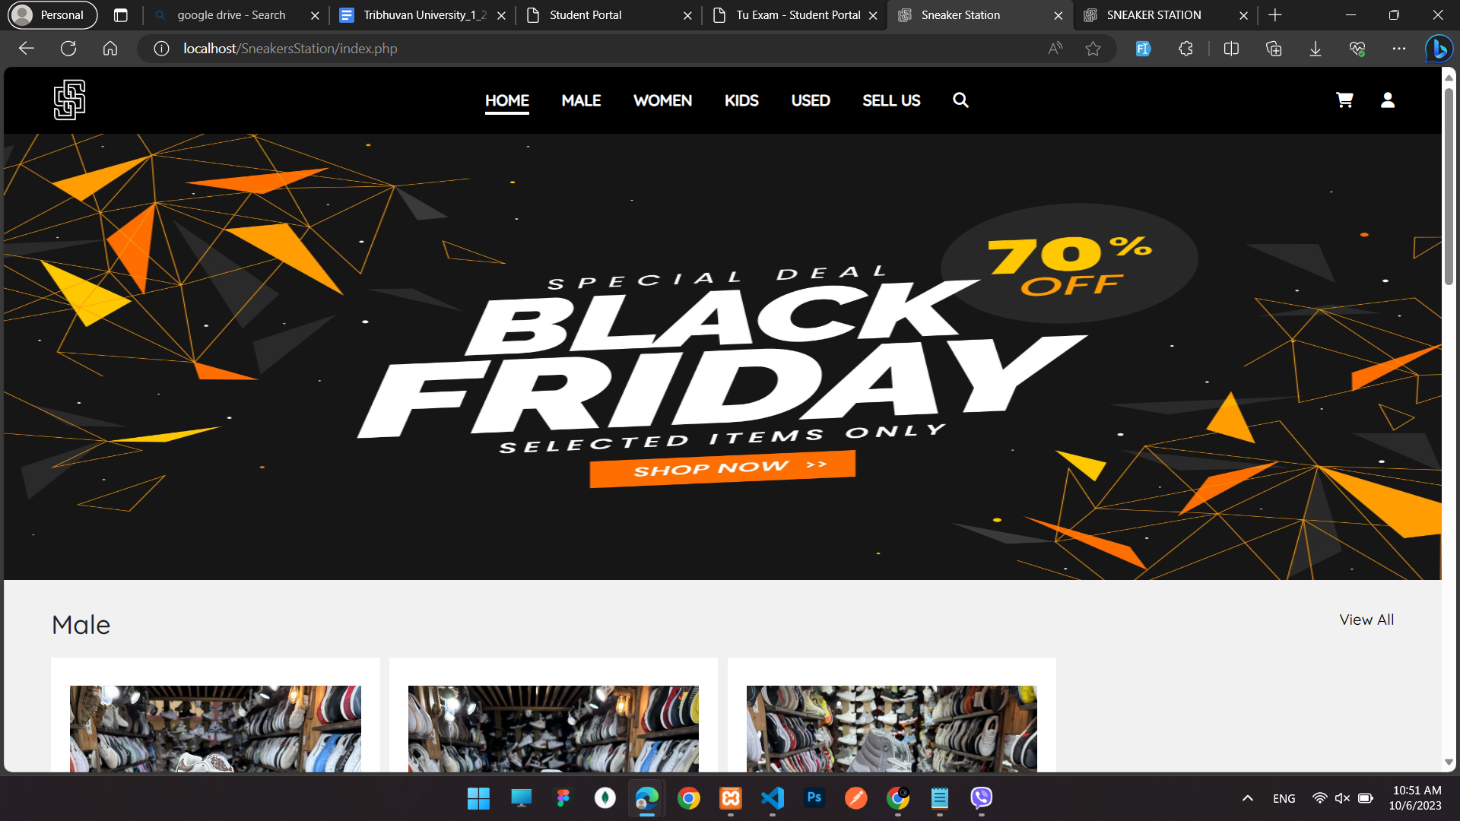

**Figure 4 Home page**

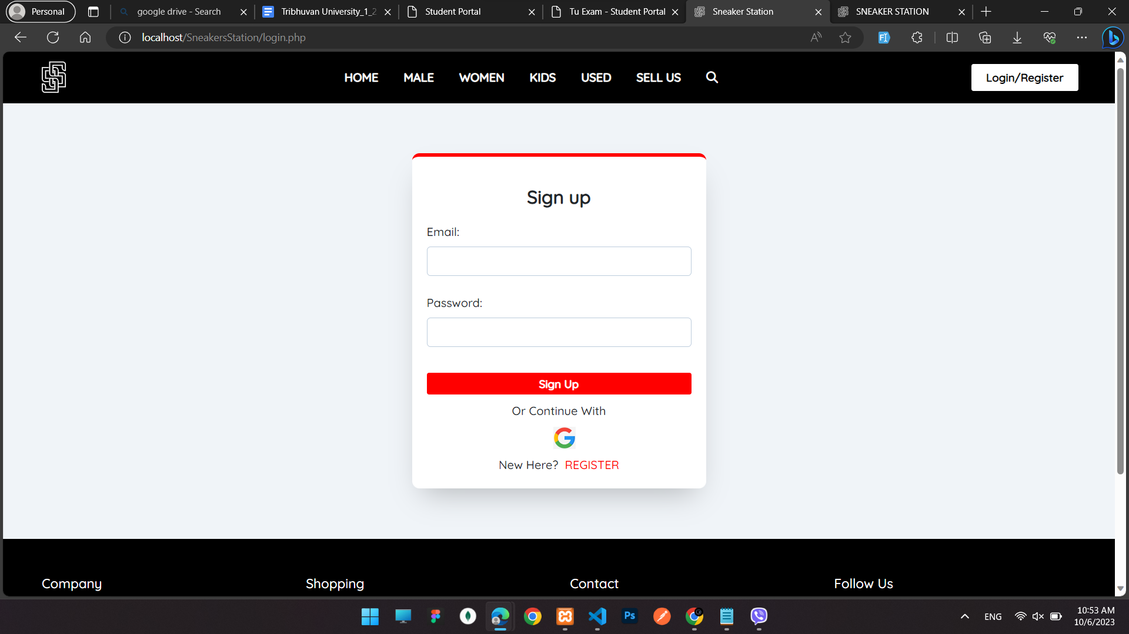

**Figure 5 Login page**

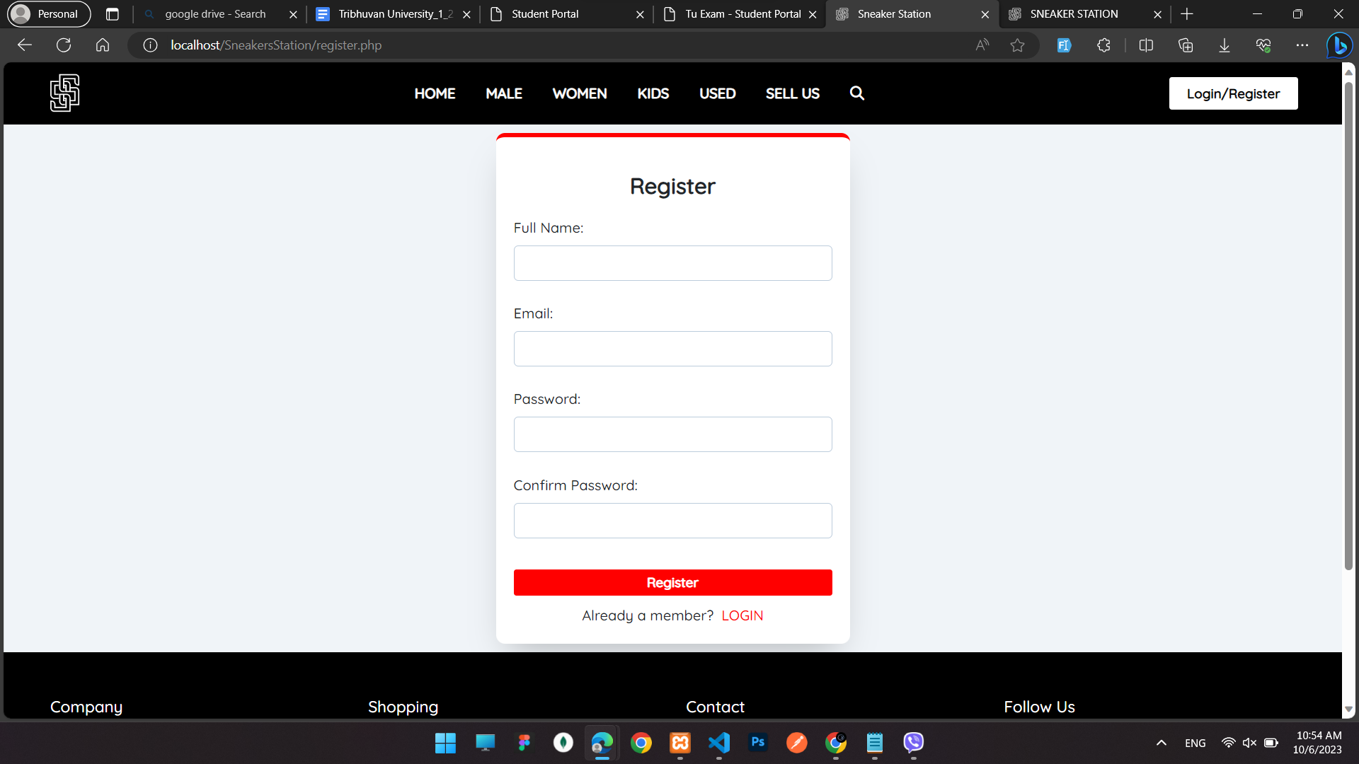

**Figure 6 Register page**

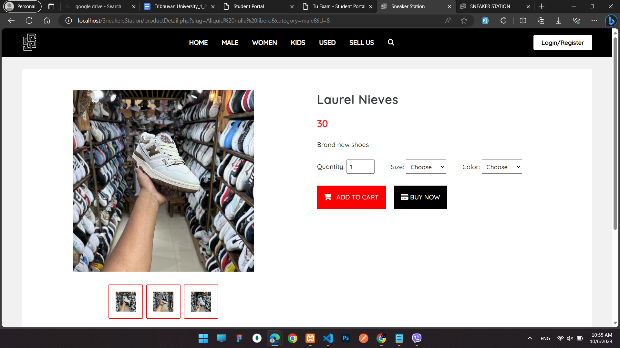

**Figure 7 Product detail page**

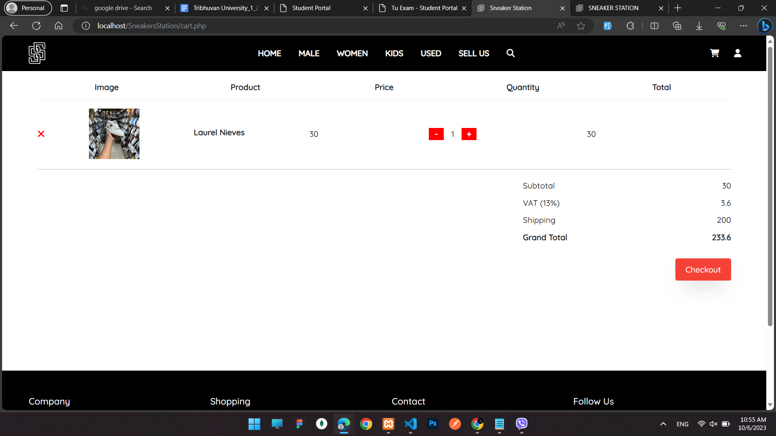

**Figure 8 Cart**

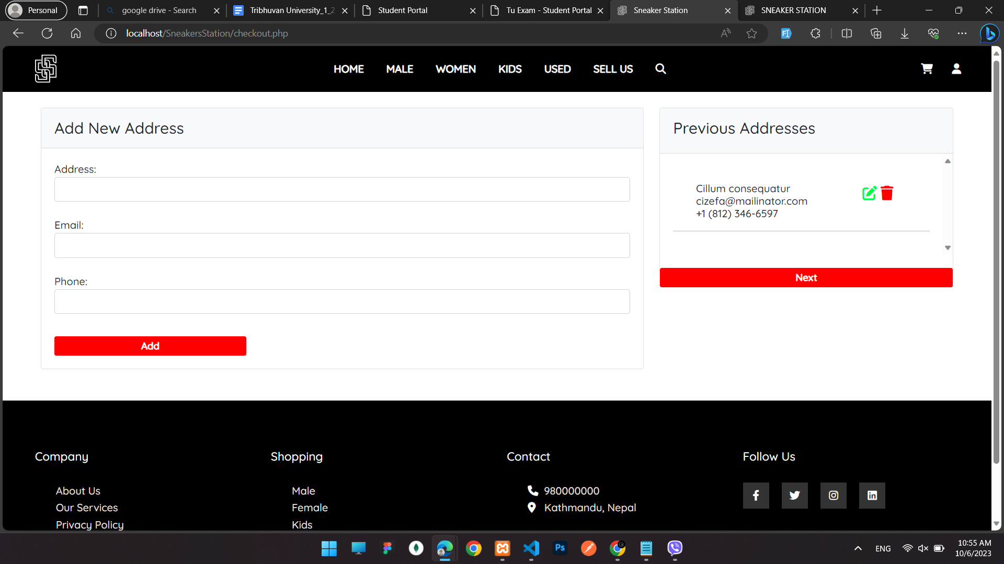

**Figure 9 Checkout**

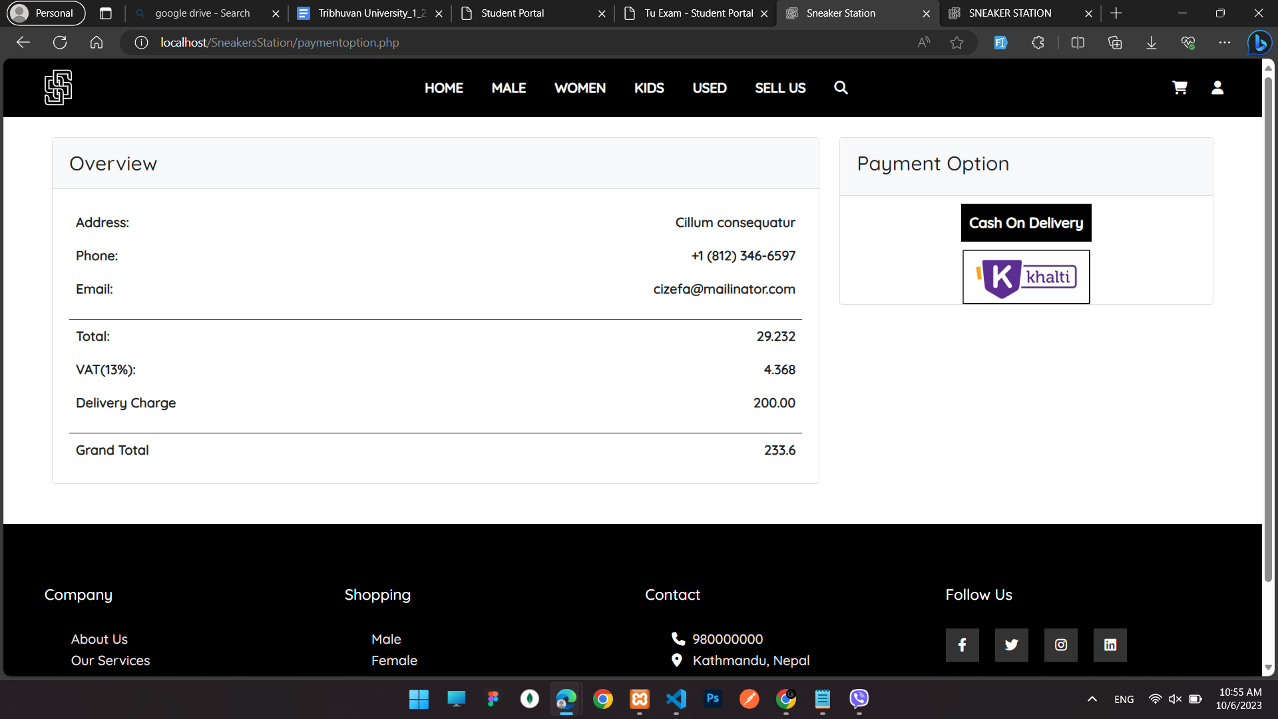

**Figure 10 Payment Option**

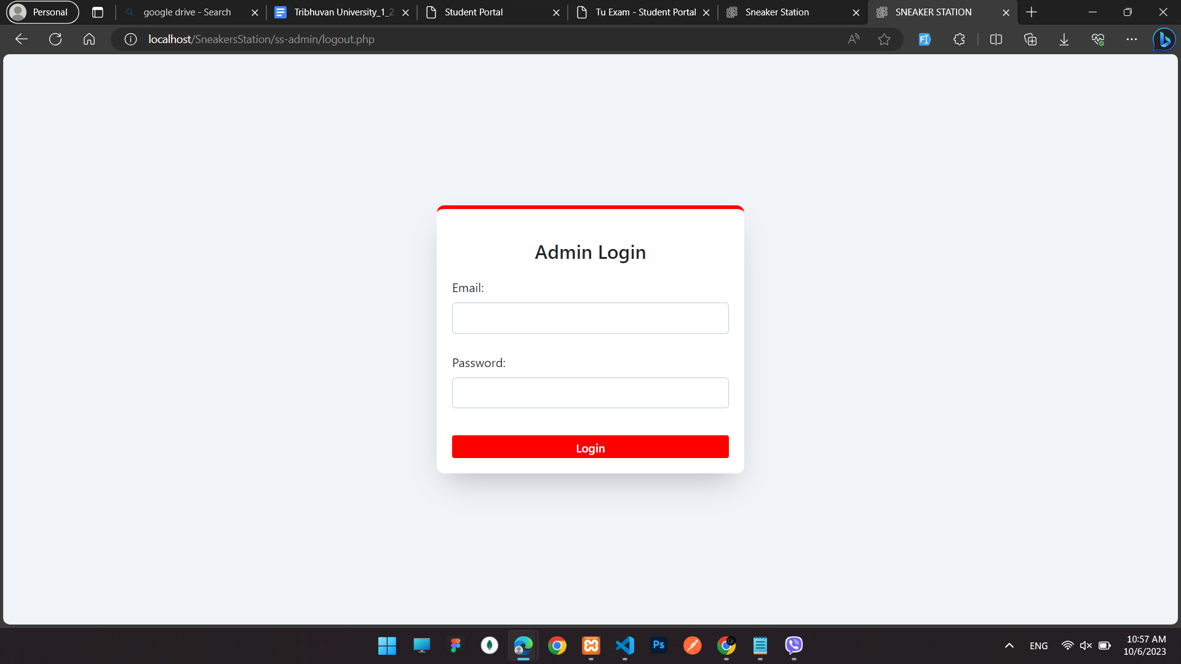

**Figure 11 Admin Login**

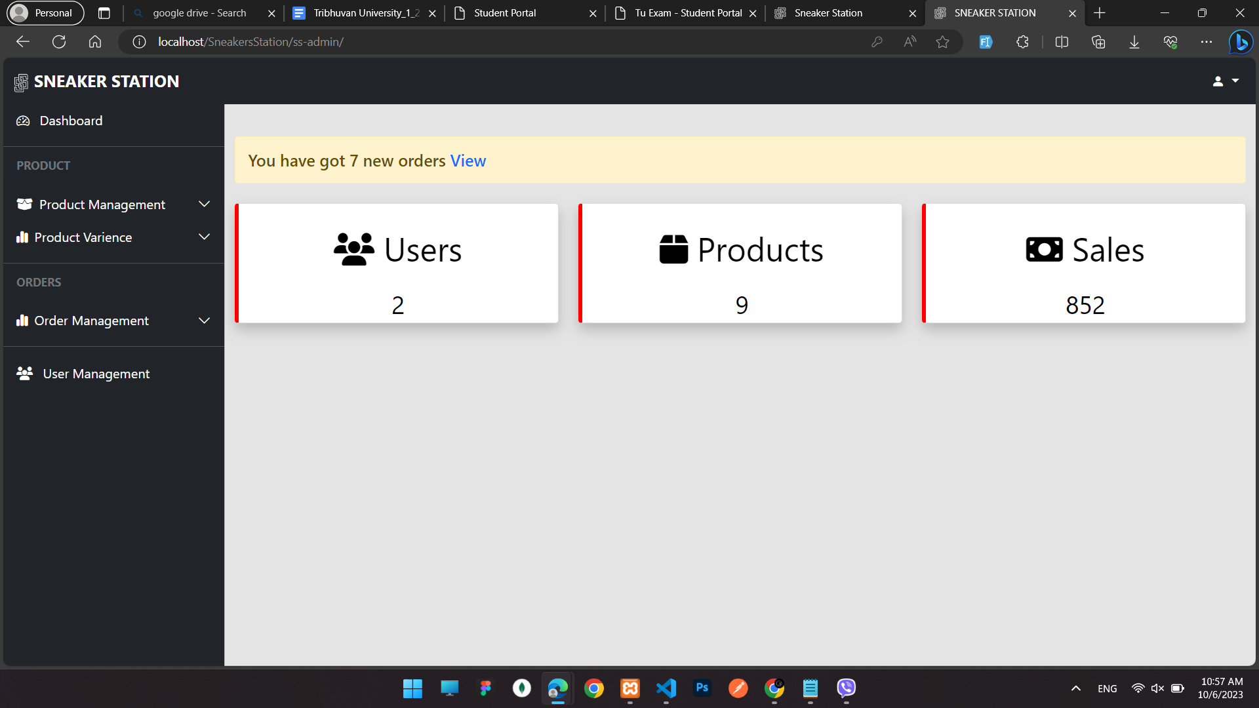

**Figure 12 Admin dashboard**

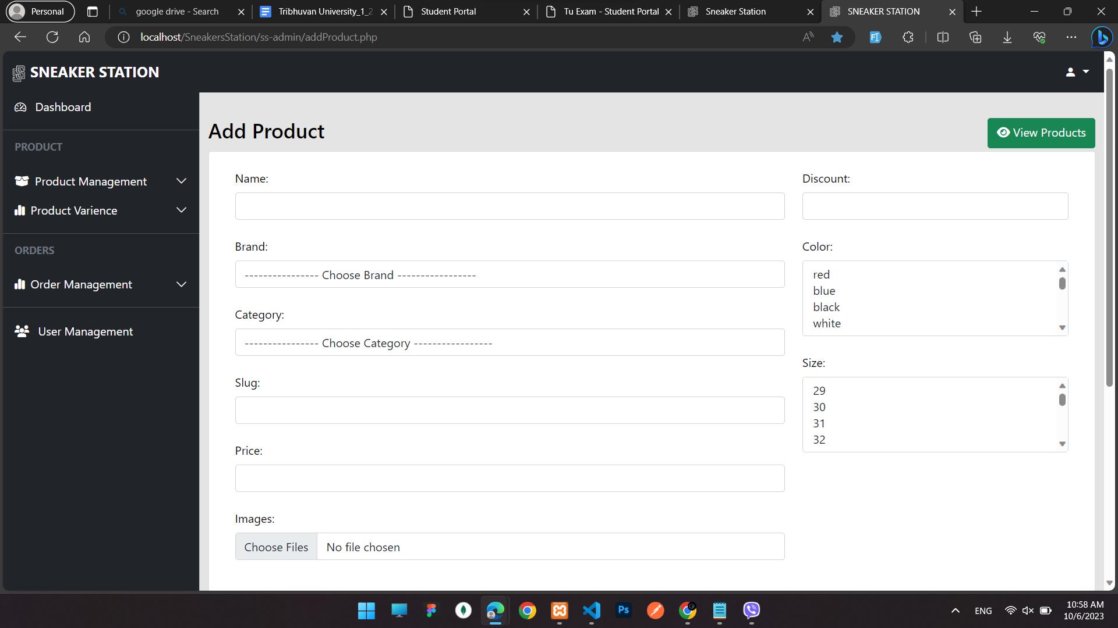

**Figure 13 Add product**

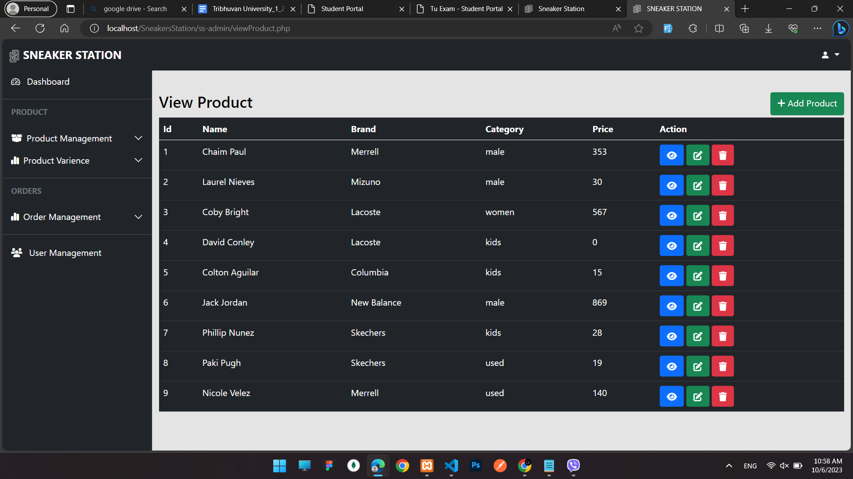

**Figure 14 View product**

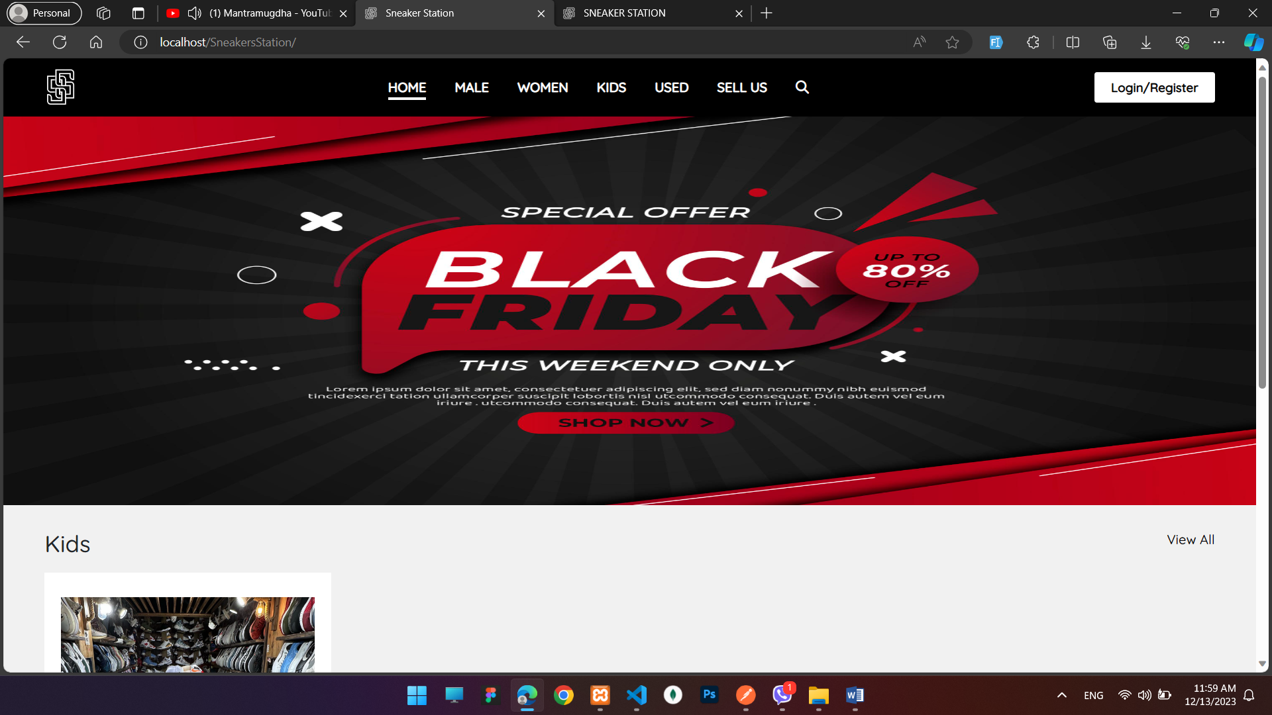

**Figure 15 Frontend View**



**Figure 16 Backend View**

# References

[1]“Retail&B2C,”AcroMedia,Mar.31,2021.https://www.acromedia.com/customers/retail-b2c (accessed june. 11, 2023). [1]

[2] Nguyen Le Thai, Hoa. (2021). The impact of e-retailer personality and website quality on online impulse buying.(accessed on 02 july, 2023)

[3]Shergill, Gurvinder & Chen, Zhaobin. (2005). Web-based shopping: Consumers' attitudes towards online shopping in New Zealand. Journal of Electronic Commerce Research. 6.(accessed on 03 july, 2023)

[4]BoPing Z. Analysis on the current situation and future development of sneaker resale market. In6th International Conference on Financial Innovation and Economic Development (accessed on 14 july, 2023)

[5] Tu YT, Chih HC. An empirical study of corporate brand image, customer perceived value and satisfaction on loyalty in shoe industry. Journal of Economics and Behavioral Studies.( accessed on 03 august, 2023)

[6] Wang CS. An analysis and evaluation of fitness for shoe lasts and human feet. Computers in industry.(accessed on 03 august, 2023)